NEW !!

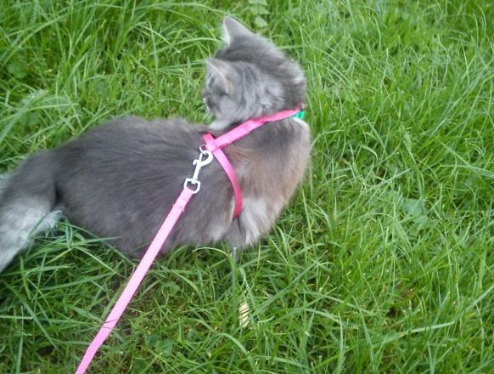
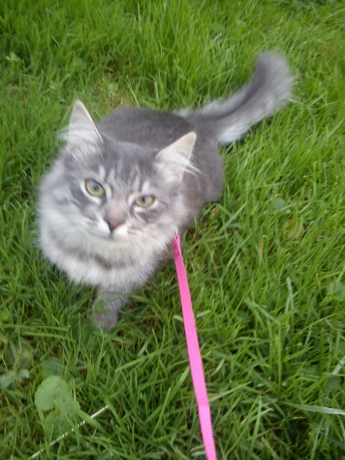
If you're afraid to let your cat go outside by itself you can buy our new product called „Queen leash“ !

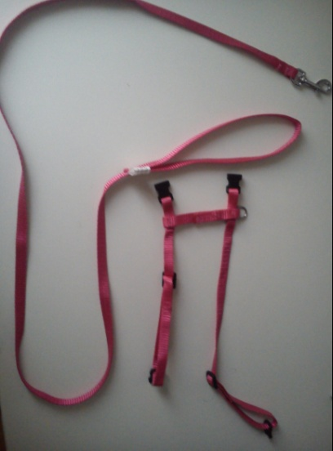
Available in black, pink and blue color!
Only $9.99 !

